Research Report on Open Source Intelligence (OSINT)



1. Introduction
Open Source Intelligence (OSINT) refers to the practice of collecting, analyzing, and disseminating information from publicly available sources to make informed decisions. OSINT can include data from online forums, social media platforms, news articles, blogs, government reports, and other open sources. OSINT has become increasingly crucial in various sectors, including cybersecurity, law enforcement, military, corporate intelligence, and journalism.

2. Importance of OSINT
OSINT is essential for several reasons:
- Cost-Effectiveness: It leverages publicly available information, reducing the need for expensive and resource-intensive intelligence operations.
- Broad Coverage: OSINT provides access to a vast amount of data that can be used for trend analysis, threat detection, and situational awareness.
- Timeliness: Information is often available in real-time or near real-time, which is crucial for decision-making in dynamic situations.
- Transparency: OSINT relies on openly accessible information, making it easier to validate and verify sources.

3. OSINT Tools
There are several tools and techniques used in OSINT, each tailored to different types of data sources and analytical needs. Below are some of the most popular OSINT tools with examples of how they are used:

3.1. Maltego
- Description: Malt ego is a graphical link analysis tool that allows users to mine and gather information from open sources and visualize the relationships between the data.
- Use Case: A cybersecurity analyst uses Maltego to map out the infrastructure of a phishing campaign by visualizing the connections between domain names, email addresses, and IP addresses.
- 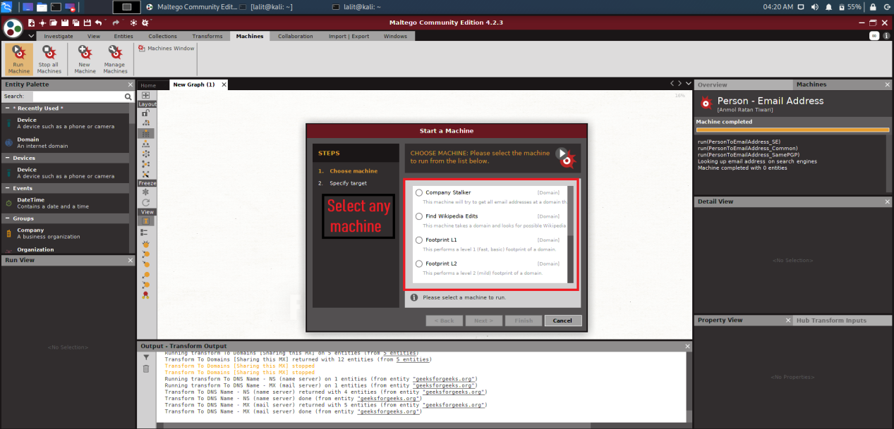

3.2. Shodan
- Description: Shodan is a search engine for internet-connected devices, often dubbed the "Google for hackers." It allows users to discover vulnerable devices connected to the internet.
- Use Case: A security researcher uses Shodan to find industrial control systems (ICS) that are exposed to the internet, identifying potential vulnerabilities in critical infrastructure.
- 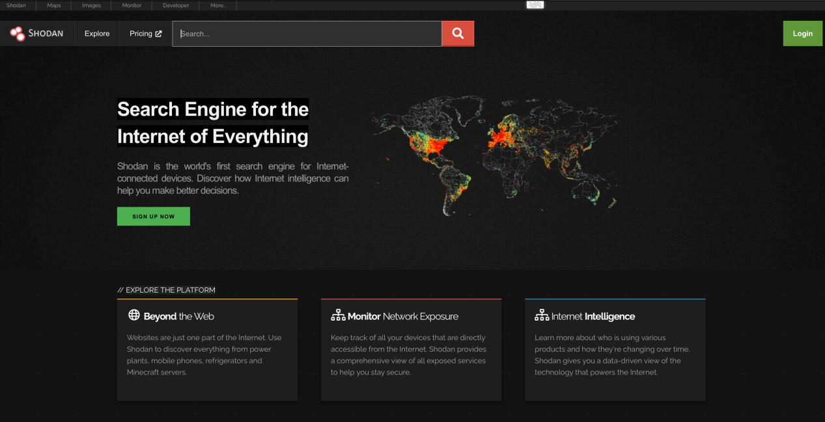

3.3. Google Dorks
- Description: Google Dorks refers to using advanced search queries in Google to find specific information that might not be easily accessible through standard search methods.
- Use Case: An investigator uses Google Dorks to find sensitive documents exposed on the internet, such as login credentials or confidential reports.
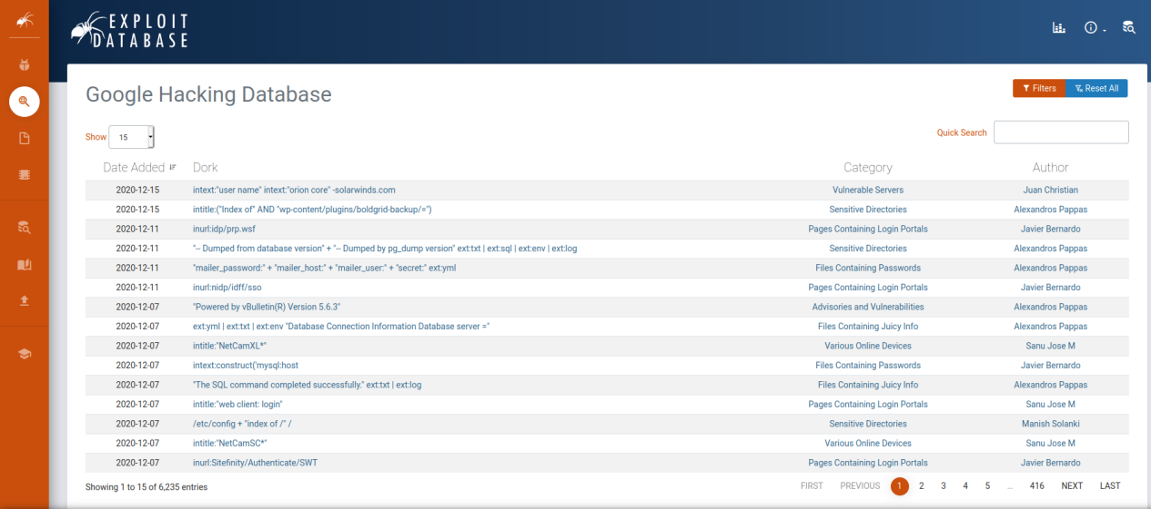

3.4. theHarvester
- Description: theHarvester is a tool designed to gather email addresses, subdomains, IPs, URLs, and more from different public sources like search engines and PGP key servers.
- Use Case: A penetration tester uses theHarvester to gather a list of subdomains for a target organization during the reconnaissance phase of a security assessment.
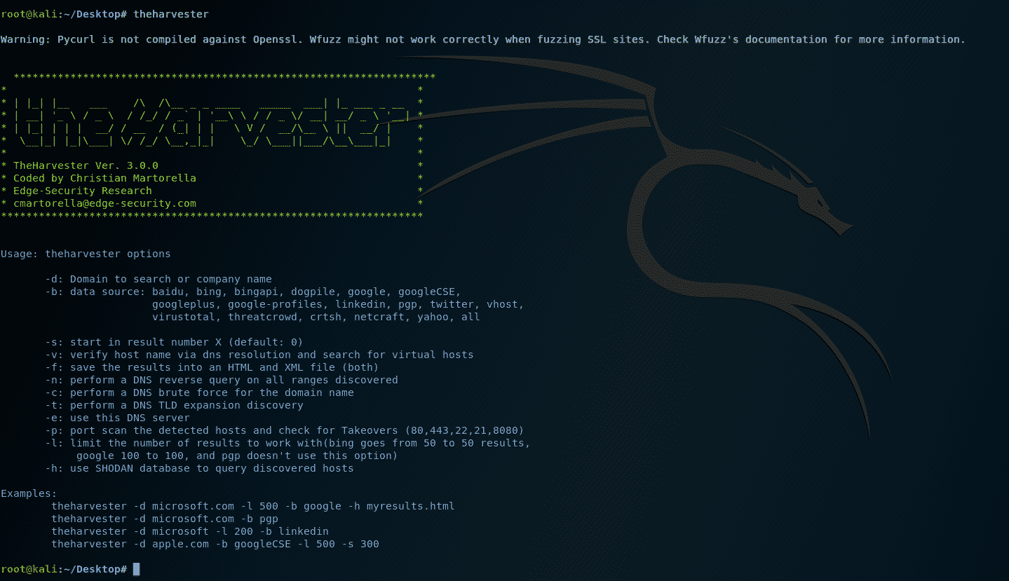

3.5. SpiderFoot
- Description: SpiderFoot is an automated OSINT tool that can gather a wide range of information from multiple data sources. It is highly customizable and can be used for threat intelligence, digital footprint analysis, and more.
- Use Case: A cybersecurity firm uses SpiderFoot to perform a deep investigation into an individual’s digital footprint, identifying all public information associated with their online identity.
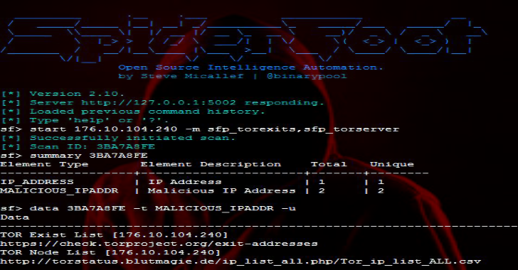

3.6. Social-Engineer Toolkit (SET)
- Description: SET is a collection of tools specifically designed for social engineering, including phishing campaigns, credential harvesting, and more.
- Use Case: An ethical hacker uses SET to create a phishing campaign to test the security awareness of employees in an organization.
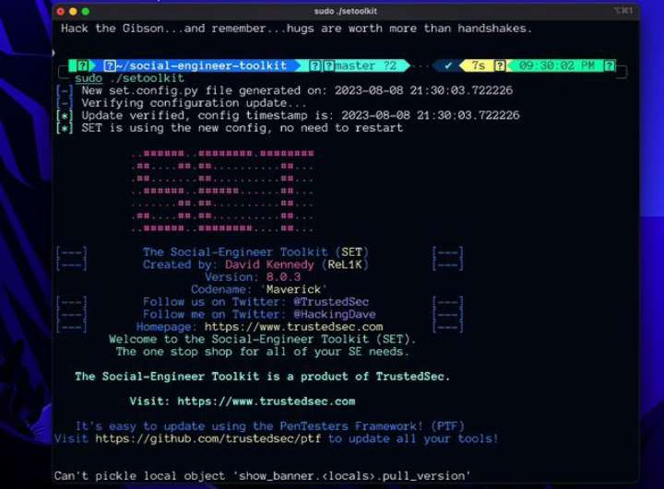

3.7. Recon-ng
- Description: Recon-ng is a full-featured reconnaissance framework written in Python, offering various modules for information gathering.
- Use Case: A security analyst uses Recon-ng to automate the collection of open-source information about a domain, including contact details, social media profiles, and related domains.
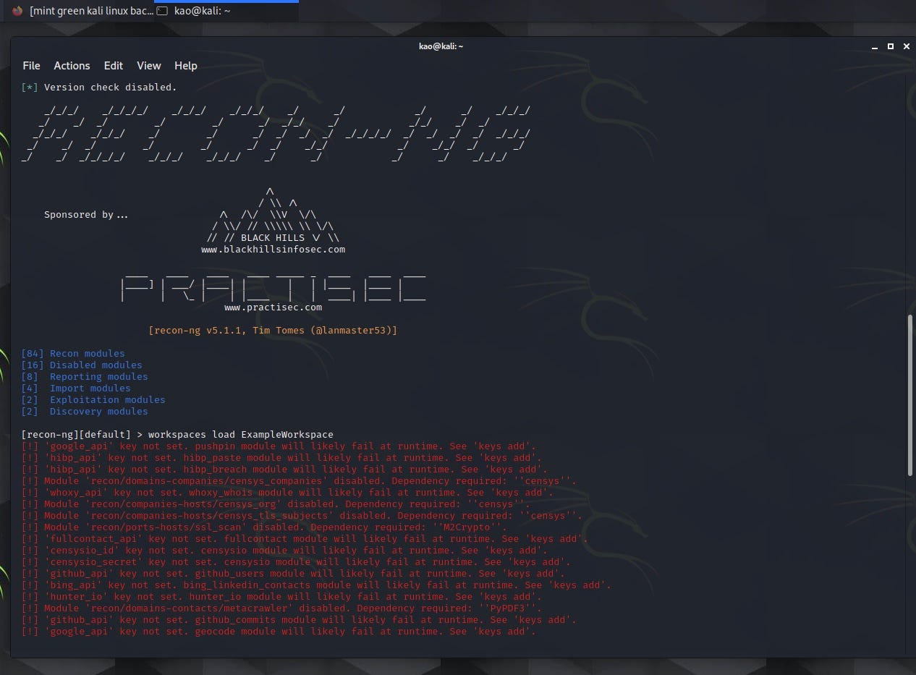

4. Ethical Considerations
While OSINT is a powerful tool, it comes with ethical responsibilities:
- Privacy Concerns: OSINT involves collecting information that, while publicly available, may still be sensitive. Ethical OSINT practitioners must respect individuals' privacy.
- Legality: It is essential to ensure that the methods used in OSINT are legal in the jurisdiction where the information is being collected.
- Bias and Reliability: OSINT data can be subject to bias, misinformation, and disinformation. Analysts must verify the reliability of the sources and cross-check information.

5. Case Studies

5.1. Tracking Terrorist Activities
- Scenario: Intelligence agencies have used OSINT to track terrorist activities by monitoring social media platforms, forums, and other online communication channels.
- Outcome: By analyzing patterns of communication and publicly available data, agencies have successfully identified and disrupted terrorist networks.

5.2. Corporate Espionage
- Scenario: A company suspected that its competitors were using OSINT to gather sensitive information about its upcoming product launches.
- Outcome: The company improved its information security practices by reducing its digital footprint and implementing stricter access controls.

6. Conclusion
OSINT is a crucial aspect of modern intelligence gathering, providing actionable insights from publicly available data. With the advancement of technology and the increasing availability of data, OSINT tools and techniques continue to evolve, offering more sophisticated and powerful capabilities. However, ethical considerations remain paramount to ensure that the use of OSINT respects privacy and legality.

References
- Maltego - Maltego
- Shodan - Shodan
- Google Dorks - Exploit Database
- theHarvester - GitHub - theHarvester
- SpiderFoot - SpiderFoot
- Social-Engineer Toolkit (SET) - TrustedSec
- Recon-ng - GitHub - Recon-ng

